Project Design Phase-II
Data Flow Diagram & User Stories
Date | 29 September 2026
Team ID | SWTID-2026-7972
Project Name | ComicCraft - AI Comic Story Creator using Gemini Models
Maximum Marks | 4 Marks

Data Flow Diagrams:
A Data Flow Diagram (DFD) is a traditional visual representation of the information flows within a system. A neat and clear DFD can depict the right amount of the system requirement graphically. It shows how data enters and leaves the system, what changes the information, and where data is stored.
The DFDs below show how a creator's story idea flows through ComicCraft, is turned into a script and panel images by the Gemini models, and is finally assembled into a comic that can be exported or shared.
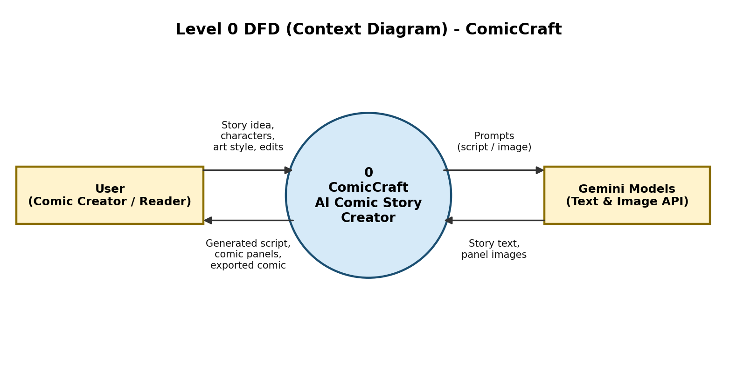
Figure 1: Level 0 DFD (Context Diagram)
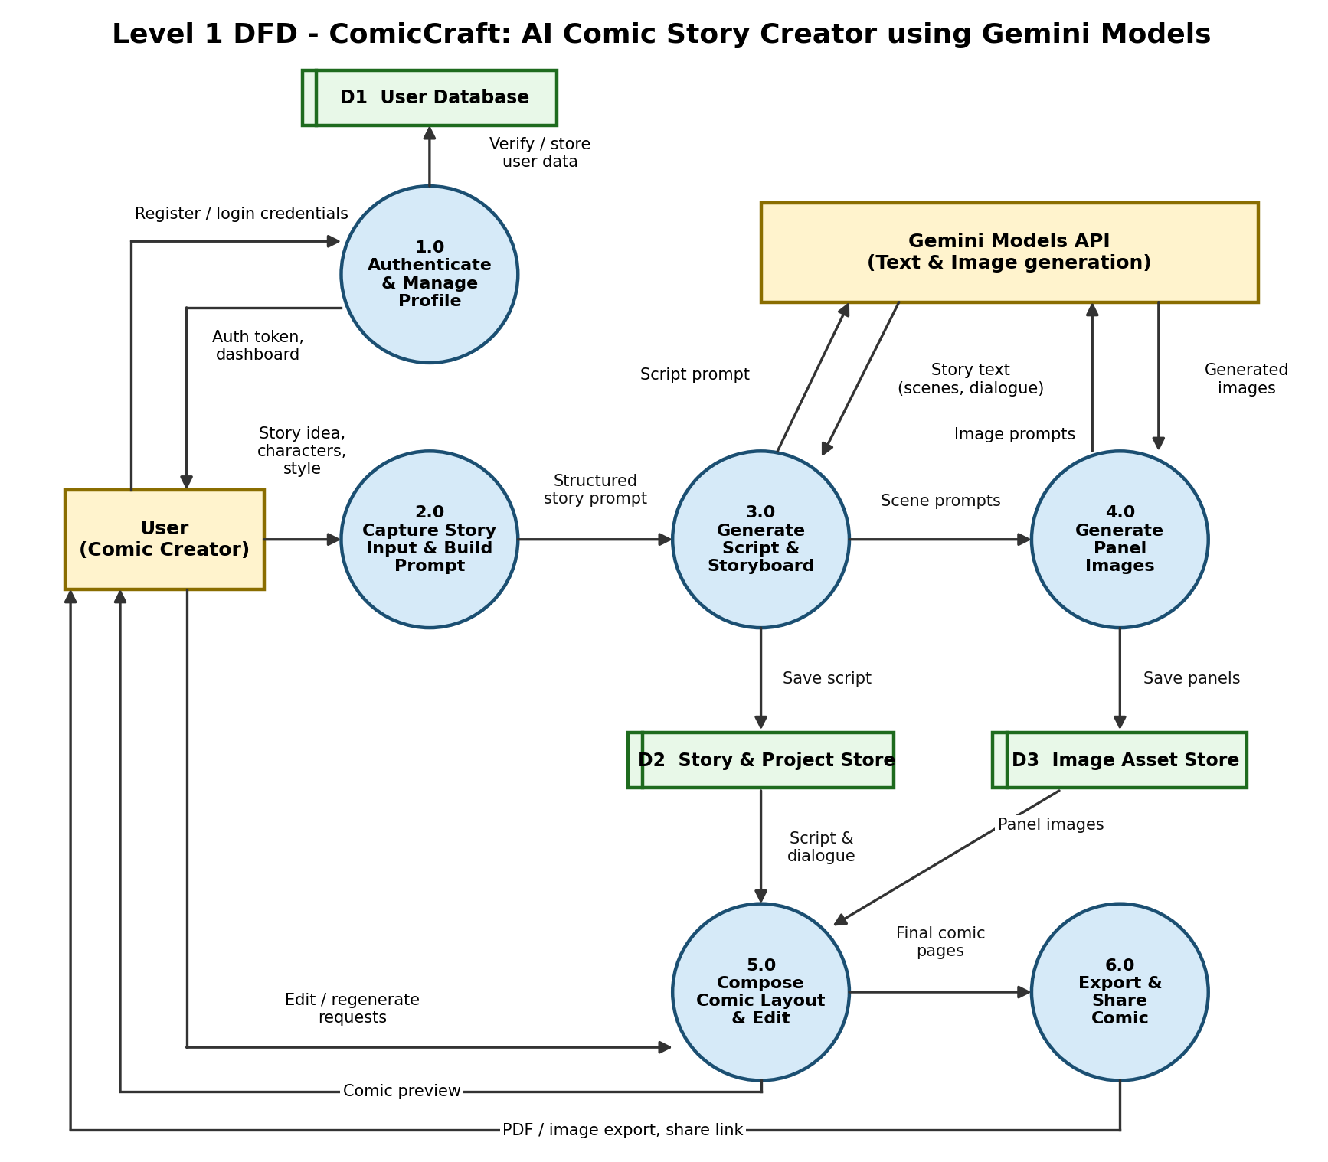
Figure 2: Level 1 DFD
Data flow summary:
- External entities: User (comic creator / reader) and the Gemini Models API (text and image generation).
- Processes: 1.0 Authenticate & Manage Profile, 2.0 Capture Story Input & Build Prompt, 3.0 Generate Script & Storyboard, 4.0 Generate Panel Images, 5.0 Compose Comic Layout & Edit, 6.0 Export & Share Comic.
- Data stores: D1 User Database, D2 Story & Project Store, D3 Image Asset Store.

User Stories
Use the below template to list all the user stories for the product.
User Type | Functional Requirement (Epic) | User Story Number | User Story / Task | Acceptance criteria | Priority | Release
Creator (Web user) | Registration | USN-1 | As a user, I can register for the application by entering my email, password, and confirming my password. | I can access my account / dashboard | High | Sprint-1
Creator (Web user) | Registration | USN-2 | As a user, I will receive a confirmation email once I have registered for the application. | I can receive confirmation email & click confirm | High | Sprint-1
Creator (Web user) | Registration | USN-3 | As a user, I can register for the application through Google (Gmail). | I can register & access the dashboard with Google Login | Medium | Sprint-2
Creator (Web user) | Login | USN-4 | As a user, I can log into the application by entering my email & password. | I can log in and reach my dashboard | High | Sprint-1
Creator (Web user) | Dashboard | USN-5 | As a user, I can view my dashboard listing all my saved comic projects. | I can see, open, rename and delete my projects | High | Sprint-1
Creator (Web user) | Story Creation | USN-6 | As a user, I can enter a story idea, genre and tone so that the app can generate a comic story from it. | The app accepts my input and shows a generated story outline | High | Sprint-2
Creator (Web user) | Story Creation | USN-7 | As a user, I can define characters (name, appearance, personality) so that they stay consistent across panels. | Characters are saved and used in every generated panel | High | Sprint-2
Creator (Web user) | Story Creation | USN-8 | As a user, I can choose an art style (e.g. manga, cartoon, realistic) for my comic. | The generated panels follow the chosen art style | Medium | Sprint-2
Creator (Web user) | Panel Generation | USN-9 | As a user, I can generate comic panels with images from the Gemini models based on my story script. | Each scene of the script is turned into a panel image | High | Sprint-3
Creator (Web user) | Panel Generation | USN-10 | As a user, I can regenerate a single panel if I am not satisfied with it. | Only the selected panel is regenerated; others stay unchanged | Medium | Sprint-3
Creator (Web user) | Comic Editing | USN-11 | As a user, I can edit dialogue, captions and speech bubbles on each panel. | My edits are shown in the comic preview and saved | Medium | Sprint-3
Creator (Web user) | Comic Editing | USN-12 | As a user, I can reorder, add or delete panels in my comic. | The comic layout updates as per my changes | Low | Sprint-4
Creator (Web user) | Export & Share | USN-13 | As a user, I can export my finished comic as a PDF or image. | I can download the comic file to my device | High | Sprint-4
Creator (Web user) | Export & Share | USN-14 | As a user, I can share my comic through a public link. | Anyone with the link can view the comic | Low | Sprint-4
Creator (Mobile user) | Mobile Access | USN-15 | As a mobile user, I can create and view my comics on my phone through a responsive interface. | All main screens are usable on a mobile screen size | Medium | Sprint-4
Reader (Guest user) | Read Shared Comics | USN-16 | As a reader, I can open a shared comic link without creating an account. | The comic opens in read-only view | Low | Sprint-4
Support Executive | User Support | USN-17 | As a support executive, I can view reported issues from users so that I can help resolve them. | I can see the list of issues and update their status | Low | Sprint-4
Administrator | Admin Management | USN-18 | As an administrator, I can manage user accounts (view, block, delete). | I can view all users and change their account status | Medium | Sprint-4
Administrator | Admin Management | USN-19 | As an administrator, I can monitor Gemini API usage and generation failures. | I can see usage counts and error logs | Medium | Sprint-4

